Initial Sample Preparation for Glasses

Chipping Glassy Rinds from Basaltic Samples
When present, glass is a precious resource for the geochemist because it easily satisfies the requirement of homogeneity for extrapolating from subsample to geologic feature scale even in very small quantities. It even contains volatile elements, which are mostly lost during eruption and crystallization of lavas. Thus, if your sample has any glassy rind preserved, it is important to sample this glass carefully. If possible, leave some glass intact on the sample.

Place dried sample in a tray with high walls, like a baking tray. Start by peeling any loose glass off with your fingers but be careful to not cut yourself or contaminate the sample with dirty gloves. To remove glass, which is stuck to the sample, gently tap the surface of the sample with a clean hammer, while shielding the hammer with the other hand to stop glass flakes from flying out of the tray. For more stubborn rinds you will need to aggressively chip the sample with the hammer and chisel. Use your non-dominant hand to hold the chisel in the pocket between your thumb and index finger. Obliquely rest the cutting edge of the chisel on the target glass, while using your fingers to shield the target glass. Hammer the chisel. Pour all of the contents of the sample tray into a fresh sample bag. Sonicate the glass as described in the sonicating chips section in the Whole Rock preparation section of this manual.

Sieving Glass Separates
A separate sample of sonicated glass chips will be required to get started with any glass analysis. Because the amount of ideal glass is such a small percentage of what is in an average sample, it is preferable to have an abundance of sample. A minimum amount of sonicated glass chips for a glass sample in good condition is a few grams. The TC/EA samples are first sieved to isolate the smaller material. Usually a 2mm sieve is the desired size fraction for picking in the following steps. However, samples which have an abundance of clays, vesicles, and crystals may require finer sieving of 1mm or less. The separated material from the sieving process is poured into new sample bags and labeled with sample identification number, and its grain size. This is the material that samples will be picked from.

Make a clean workspace on a countertop with about a square meter of working space. Lay a sheet of the 8.5x11 printer paper on the countertop and place the 2mm sieve on top of it, making sure that the sieve is completely underlain by the paper. Lay the other 8.5x11 printer paper nearby, off to the side. Pour the sample into the sieve and agitate it gently by shaking and tapping the edges, making sure to keep the edges of the sieve on top of the paper at all times. Once all of the finer material has been filtered through the sieve, carefully pour the coarser material onto the other 8.5x11 printer paper. Grains that have become stuck in the sieve can be removed onto this paper, using a pick to poke them out. Inspect the sieve closely to make sure that all grains have been removed. It is helpful to hold the sieve up against a lighter surface to check this. Then completely wipe both sides with a kimwipe. Using the 8.5x11 printer paper as a funnel, pour the coarse material back into the sample bag from which it was obtained. Label a sample bag with the sample number and the size that it was sieved to (<2mm). Using the 8.5x11 printer paper as a funnel, pour the sieved material into the sample bag.
Picking Sieved Glass
Picking of the sieved glass is performed using a microscope to carefully inspect each selected grain. The optimal grains are free of clay, palagonite, crystals and vesicles. Glass should also exhibit a shiny, black texture, without any dull or matte areas. All sides of the grains should be examined. Selected grains may be placed on the additional weighing paper until this process is completed. The picked material can then be transferred to a labeled sample vial by carefully pouring the material from the weighing paper into the vial.

Use a label maker to create a sticky label with the sample name and attach it to the sample vial. Set up a workspace around the microscope with all of the equipment within reach. Place a weighing paper on the microscope stage and adjust the light so that both the transmitted and reflected light sources are on it. Use the Scoopula to place one or two scoops of material from your sample bag onto this weighing paper. Place another weighing paper off to the side. This is where selected grains will be placed throughout the picking process. Using the tweezers, carefully look through the material for desired grains, making sure to inspect all sides before selecting a grain. Place selected grains onto the clean weighing paper next to the microscope. It may be necessary to weigh the selected grains several times throughout this process to obtain the necessary amount. To do this place the empty sample vial onto the scale and tare it to zero. Carefully pour the sample into the vial and place it on the scale. *Remember to pick more sample than what is required for the TC/EA. When enough glass has been picked, write its mass and any descriptive notes about the sample in a lab notebook. (e.g. Did it have abundant clay or vesicles, or was it a nice sample?). Use a kimwipe to wipe off tweezers and scoopula.

Initial Sample Preparation for All Geochemical Analysis in Whole Rocks

Isolate “Pristine” Sample
All geochemical analysis involves the subsampling of a geologic feature in order to scrutinize its composition in detail. It is important that your subsample is representative of the sample that you are studying. For a standard suite of geochemical analyses on aphanitic rocks like basalt, you want to start out with a baseball sized sample that is devoid of alteration. Typically, this means subsampling a hand sample’s fresh interior. This can either be done by hammer and sledge or rock saw.

Removing Saw contamination
If the sample of interest was slabbed, the saw marks must be ground from the sample with coarse (60 to 100 grit) silicon carbide paper or grit on a steel wheel. Following careful rinsing, the samples are immersed in deionized water in clean glass beakers and place in an ultrasonic bath or probe for 15-30 minutes to efficiently remove adhering grit. The samples should then be thoroughly dried in a 100°C oven for several hours prior to rough splitting.

Crushing using hammer and Sledge (for all geochemical analyses)
Cleaned rock fragments or slabs are comminuted to <2cm by wrapping them in several polyethylene plastic bags and careful hammering. Care must be taken to minimize or avoid contact of the hammer or baseplate with the sample.

The crushed sample can be sieved to isolate material for desired chemical analyses. Required sample masses for each size fraction that needed for analysis are provided below along with their respective recommended sieve fraction.

>2cm (<10% of original sample) – recrush using another set of clean plastic bags using
the hammer.
2cm to 2mm (50-100g) – good for XRF, assuming your samples are devoid of alteration
1-2mm (1g) – ICPMS trace elements (50 mg), Sr-Nd-Pb isotopes (300 mg)
<1mm – Save in case you want to do mineral specific analysis, or you don’t have enough material for other trace elements.

Once you have enough material in each of these sieve fractions, you are done. If you do not have the desired sample in the smaller size fractions for what you need, move on to jaw crushing.

Jaw-Crushing
The small ceramic jaw crusher is used to further comminute bulk samples to the sub-centimeter-size necessary for powdering in the Shatterbox. Feed material must be <2 cm in diameter following from careful sledging of the bulk sample. The jaw crusher is first cleaned by rubbing the plates with a coarse grit SiC adhesive paper on a flat wooden stick (e.g. a paint stirring stick); use a cotton-tipped stick to remove any residue from the joins between the ceramic plates. After blowing out with compressed air, start up the crusher and pass several rounds of coarse bull quartz through the plates. Again use a cotton tipped stick to remove residual quartz from joints while blowing with compressed air. Finally start up the crusher and pass several rounds of excess sample through the plates to pre-contaminate the plates—discard this sample and blow off excess. The jaw crusher is now ready to crush your sample. Clean through the quartz step when your finished with the device.

Sonicating Chips
In order to remove any contamination from the hammer and plate, and make visible altered sample, it is recommended that all samples for XRF are cleaned in an ultrasonic bath prior to powdering. For this, pour your sample into a clean beaker that is large enough to be no more than 1/3 full of your chips. Fill the beaker with tap water to 2/3 full, swirl and decant the cloudy suspension. Repeat until suspension is clear of fines. Fill the beaker 2/3 full with 1% H2O2 and sonicate for 20 minutes. This step removes any surficial contamination but can leach trace elements from your samples, so it is critical to not leave samples in this solution for longer than 20 minutes. Depending on the desired analysis this step can be skipped. Decant the solution and rinse with MQ water, swirling each time, until the water is clear. Sonicate in Milliq H2O at 20-minute intervals two times, rinsing in between with Milliq, or until water is clear after sonicating. Dry the chips in a drying oven at 150C or less or another clean space.

Sample Preparation for XRF

Picking Samples to Be Powdered
Before powdering, pick the sample clean of altered or undesirable contaminants. Pour a subsample of the sonicated 2mm to 2cm size fraction of your sample onto a clean weigh paper or petri dish. Pour enough sample out so that it makes a single layer on your picking surface. Using a binocular microscope or naked eyes, remove any undesirable chips. Dump the picked remains into a separate container for powdering. Repeat until you have 20-50 g of sample. Remember though, the more sample you have in the end the better you will be able to represent the average composition of the rock you initially subsampled, this is especially true for major element analysis. Also, by working with large sample volumes, you reduce the effect of contamination.

The Shatterbox (for powders)
The Shatterbox comprises a tungsten-carbide lined sample chamber clamped into a holder sitting on an eccentric spinning shaft which spins a ceramic puck inside the chamber. Collisions efficiently grind the sample material to a fine powder within minutes for most rocks. Prepare the workspace by removing the tungsten rings from their box and return the box and packing to the cabinet. It should be very clean at this point, if not, start at the post sample cleaning phase.

Precontamination Step: Carefully place the ring and puck into the dish, without dropping them. Center the ring and puck, making a bulls-eye pattern. Add 8-10g of sample into the ring mill, distributing evenly throughout the negative space of the bulls eye. If all the sample is in one place it can jam up the rings preventing even powdering. It is recommended to use an electronic balance to determine sample mass. Never operate the ring mill with less than 8 g of sample as it accelerates wear to the WC. Secure the o-ring and lid on the dish and put into the shatterbox. Clamp the lid of the shatterbox making sure it is secure. The clamp should be vertical and handle all the way down over the dish. Turn on the shatterbox for 30 seconds.

Remove the dish and setup a pice of paper onto a plastic cutting board for collecting sample. Carefully remove the puck and disk from the mill, tapping them onto the paper covered cutting board to free the sample. Clean the remaining powder from each surface onto the same piece of scrap paper using a clean paint brush and discard this powder. Use compressed air to blow the ring mill parts clean. Thoroughly blow out the paintbrush until no powder is visible on the bristles.

Sample Powdering Step: You are now ready to powder your sample. Follow the procedure from the precontamination step to load 15-25 g of sample into the mill. Powder the sample for 2 minutes in the mill.

Similar to the precontamination step, remove the dish from the shatterbox and carefully clean the sample powder onto a clean 8 1/2 x 11” piece of printer paper. Dump the sample powder into a clean screwtop Tupperware and label the container. Add the sample name to the shatterbox log book.

Cleaning Step:
Once the rings are sufficiently free of most sample powder, blow off each piece using compressed air. Be sure to remove the rubber o-ring from the dish and clean out the powder from underneath. Use a red or green scouring pad with a few drops of ethanol to manually clean each WC piece of the mill. You will be able to feel the smooth surface of the WC when all of the sticky powder is removed. Blow each piece clean and wipe down with a clean paper towel. Wipe the o-ring with a paper towel. Blow out the rings a final time and replace the o-ring back on the dish.

Add 10 grams of acid-washed quartz chips to the shatterbox and powder for two minutes following the procedure laid out in the precontamination steps. If you are using the ceramic ring-mill set you can use water in the cleaning step and run the mill for 10 minutes.

Clean out the rings following the procedure laid out in the precontamination step. Dump the quartz powder into the appropriately labeled screwtop Tupperware. Reclean the ring mill following the steps in the first paragraph of this step. The ring mill should now look very clean, with no visible sample residue.

Sample Preparation for ICPMS trace elements and isotopic analysis by TIMS

Picking Samples for dissolution
Before powdering, pick the sample clean of altered or undesirable contaminants and phenocrysts. Pour a subsample of the sonicated 1mm to 2mm size fraction of your sample onto a clean weigh paper or petri dish. Pour enough sample out so that it makes a single layer on your picking surface. Using a binocular microscope or naked eyes, remove any undesirable chips. Dump the picked remains into a separate container for dissolution. Repeat until you have 50-100 mg of sample for ICPMS and or 300 mg of sample for TIMS. Once you have enough material, dump it out onto the weigh paper and check it for phenocrysts and altered samples one last time before setting aside for analysis.

Sample Preparation for hydrogen isotopes by TC/EA

Crushing Picked Glass
Crushing will be performed by enclosing the sample within a folded weighing paper and applying a force to carefully crush the material. This is usually done by pressing a hammer head onto the sample and rocking it back and forth while applying pressure. Do not attempt to smash the sample by swinging the hammer, as this will damage the counter top and is not an efficient method for crushing fine material. The crushed material will be sifted to <300 microns. Crushing the glass will require repeated steps of crushing, sifting, re-enclosing the remaining sample in a new weighing paper, and crushing again, until all of the sample has been sifted to <300 microns.

Equipment:
- Picked glass in vial from previous step
- Hammer
- Scoopula
- 300 micron screen
- Lab notebook
- Scissors
Expendables:
- An ample supply of 6x6 weighing papers
- Kimwipes
- 70 micron mesh
Procedure:
- Set up a workspace on a countertop with about a square meter of working space.
- On the countertop lay out equipment within reach.
- Place the 300 micron screen onto a clean weighing paper and set it to the side.
- Empty the sample onto a new weighing paper from its labeled sample vial.
- Create an envelope by folding the weighing paper in half horizontally, then into thirds vertically, making sure to keep all of the sample together and towards the bottom center during this process.
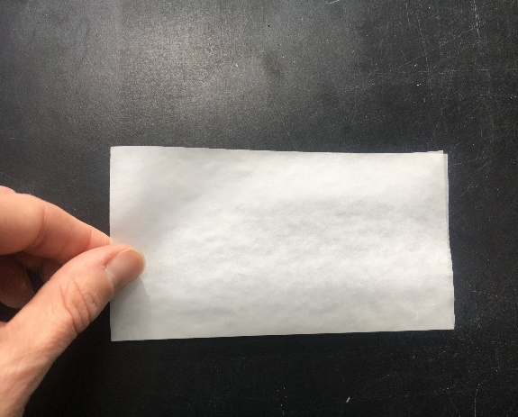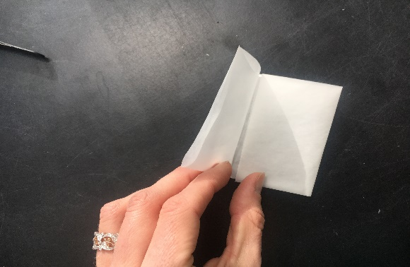

- Fold the bottom ~1 cm that contains the sample up twice.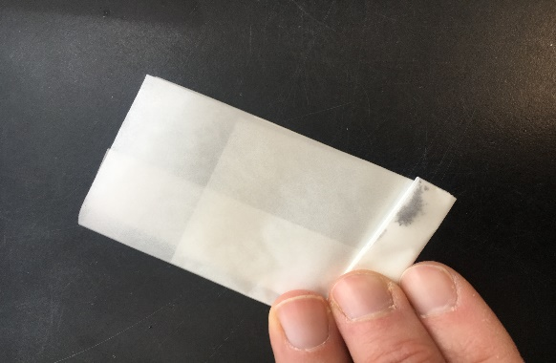
- Place this folded envelope within a new weighing paper that is folded in half. 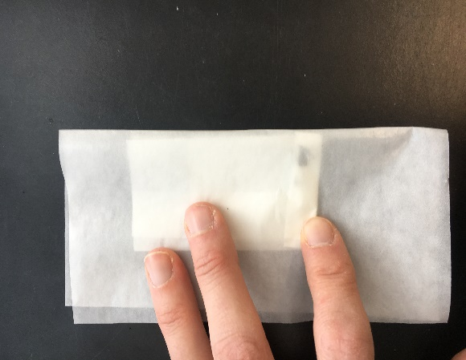
- Press the hammers head firmly against the sample and rock it back and forth. The hammer can be re-adjusted and rocked back and forth several times. 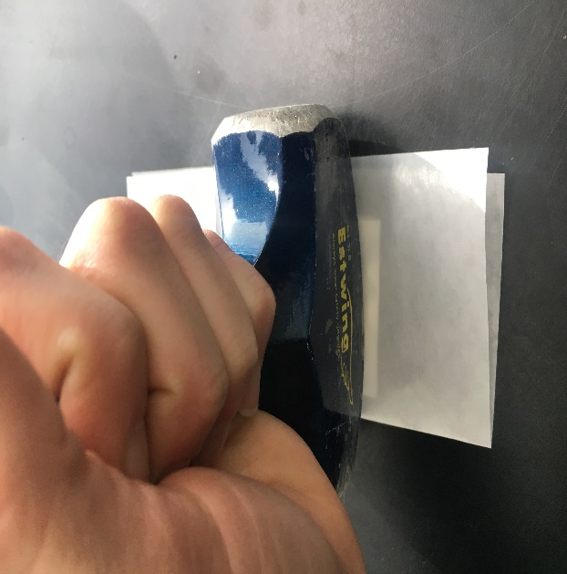
- When the glass begins to poke holes into the envelope, or when it does not feel like crushing is occurring any longer, it is time to sift the crushed material.
- Carefully open the envelope over the 300 micron screen that was placed on top of a weighing paper.
- Using the Scoopula, gently scrape the remaining material that has become embedded in the envelope over the screen. This will help to minimize the amount of material that is lost throughout this process.
- When all of the material has been removed from the envelope, it may be thrown away.
- Carefully pick up the 300 micron screen to ~1 inch above the weighing paper to allow the material to fall through. Tap the edges very gently. The screen is flimsy so it is helpful to hold the screen so that it dips in the center, and the material is concentrated there. This makes the material less likely to fall off.
- When all of the material that is less than 300 microns has been sifted, the coarser material will be carefully poured onto a new weighing paper and an envelope will once again be created for another round of crushing.
- Between crushing cycles, work the sifted material into the center of its weighing paper so that the material is concentrated there, and less likely to escape.
- It will require numerous cycles to completely sift the material to <300 microns.
- When all of the material is sifted to <300 microns, place the sample vial on the scale and tare it to zero.
- Carefully pour the crushed sample back into its sample vial.
- Cut a piece of 70 micron mesh that is a bit larger than the opening of the vial. Place the mesh over the top and secure the cap over this.
- Shake the vial for ~ 30 seconds to sift material that is finer than 70 microns into the cap.
- Remove the cap, throw away the piece of mesh, and tap the lid to remove the material. (A kimwipe may also help to remove this material).
- Place the cap back on the vial and place on the scale to obtain its crushed weight.
- Write the weight of the crushed material in a lab notebook.
Weighing the Crushed Samples
Equipment:
- Microbalance
- Silver capsules
- Capsule stand
- Scooping tools
- TC/EA experiment sheet
- Oven trays
- TC/EA clear sample holder
Expendables:
- Ample supply of weighing papers
- Kimwipes
The samples will be loaded into silver capsules for TC/EA analysis. Precise measurement of sample mass is required for accurate results, so it is necessary to use a microbalance to weigh out the samples. This step should be performed using gloves to avoid any skin contact with the capsules. You will obtain a TC/EA experiment sheet which will be filled out with sample identification numbers and the samples required mass. You will fill this out for both the standards and the samples.
- Set up a work space at the microbalance. You will perform these steps over weighing papers so place one or two sheets to the side of the microbalance to provide adequate work space. Set out the silver capsule stand and place the scooping tools within easy reach. Personal preference will dictate which scooping tool is preferred. Place the TC/EA experiment sheet within reach to reference for your measurements.
- Carefully open the TC/EA silver capsule container over a weighing paper and use tweezers to remove one capsule. The 8x5mm capsules work well for samples up to ~40mg.
- Place the capsule on the microbalance and tare it to zero. It is important to only open the microbalance for brief moments, so close it again to obtain measurement results and always close the door in between measurements.
- Using the tweezers, place the silver capsule on the capsule stand. It may be inserted into one of the holes on the stand or, if preferred, you can simply stand it up on the stand.
- Using one of the scooping tools obtain a small amount of sample from the sample vial and carefully dump it into the silver capsule.
- Weigh the capsule, and then proceed to add more sample. It will be necessary to take a number of measurements while weighing to obtain a precise measurement. Final measurements should be within 0.05 mg of the target mass.
- When a final measurement has been obtained, write this mass in the designated column of the TC/EA experiment sheet.
- The samples should then be placed, open, into oven trays in their corresponding labeled positions for subsequent drying, outlined in the next set of instructions.
- The standards may be closed by pinching the top shut using tweezers. Use a kimwipe to carefully hold the capsule in one hand and use the tweezers to then fold down the pinched top, folding both of the corners in and very gently manipulating it to a small rounded shape. Place the closed standard sample in its corresponding labeled spot in a clear TC/EA sample holder.
- The capsule stand should be cleaned in between each sample measurement to avoid cross contamination. This can be done by turning upside down over a garbage can, using a kimwipe, and even blowing on it to help dislodge any sample that may have fallen into the holes. The scooping tools and tweezers should also be wiped with a kimwipe in between each sample.
- Repeat these steps for both the standards and samples.
Drying the Samples
For oceanic glasses, it is necessary to remove secondary hydration by seawater from the samples. This can be done by drying the samples, in their open silver capsules, in an oven at 150°C for two hours. This drying technique has been previously determined, through experimentation, to best remove additional water from the sample.
After the samples have been dried, the silver capsules may then be closed in the same manner as previously performed on the standards and they may be added to their corresponding labeled spots in the clear TC/EA sample holder.
The samples are now ready to load into the TC/EA.

