Instructions for making a carousel for shrink-teflon microcolumns
for U-Pb ion chromatography

Materials:
Spin Tray, 13" diam. x 1-1/2" h — Container Store #564010
http://www.containerstore.com/shop?productId=10007006&N=&Ntt=spin+tray
3 qt. Round Keeper 2.8 ltr., 7-1/4" diam. x 5-1/4" h — Container Store #10029313
http://www.containerstore.com/shop?productId=10014891&N=&Ntt=3+qt.+round+keeper
1/8” acrylic sheet — McMaster-Carr
http://www.mcmaster.com/#plastics/=awm9fm
12 - #8-32 x 1” plastic (nylon or other) machine screws (binder head) — McMaster-Carr
http://www.mcmaster.com/#machine-screws/=ax383s
12 - #8 x 1/16” thick plastic flat washers (nylon or other) — McMaster-Carr
http://www.mcmaster.com/#washers/=ax39qm
12 - #8-32 x 1” plastic machine screw nuts (nylon or other) — McMaster-Carr
http://www.mcmaster.com/#plastic-hex-nuts/=ax3aih
4 - #8 x 3/8” dia. x 1/2” h plastic spacer (nylon or other) — McMaster-Carr
http://www.mcmaster.com/#spacers-and-standoffs/=ax4b22

Tools:

saw
drill
3/8” drill bit
razor blade
wire cutter
Sharpie

Instructions:
- The lip of the spin tray should first be trimmed off with a saw, and then four 3/16” dia. holes drilled through the tray, along a radius 3-3/16” from the center of the tray.
- Push four plastic #8-32 machine screws through the 1/2” spacers and then through the top of the tray, and fasten with washers and nuts. Closely trim off the end of the machine screw with a wire cutter. The machine screw heads with spacers serve as guide posts for the circular band made from the round keeper.
- Cut the bottom off of the round keeper, 2” from the top, preserving the neatly trimmed upper band. The bottom can be discarded, or used as a wash tray. The circular band can now be placed right-side up onto the spin tray, friction fit around the machine screw posts.
- Have a machine shop fabricate the disk and ring pieces illustrated on the next page from 1/8” acrylic sheet. Align the ring above the disk, with the beveled edges facing each other, and insert a plastic #8-32 machine screw from the bottom through the disk, add a washer between the disk and the ring, and fasten the ring to the disk with a nut. Repeat with all 8 holes, and closely trim off the end of the machine screw with a wire cutter. Place the coupled disk and ring onto the circular band (ring up), friction fit around the machine screw heads.
- Label 16 spaces around the circumference of the spin tray with the Sharpie marker; the three pieces of the tray can be easily disassembled and wiped clean between uses.

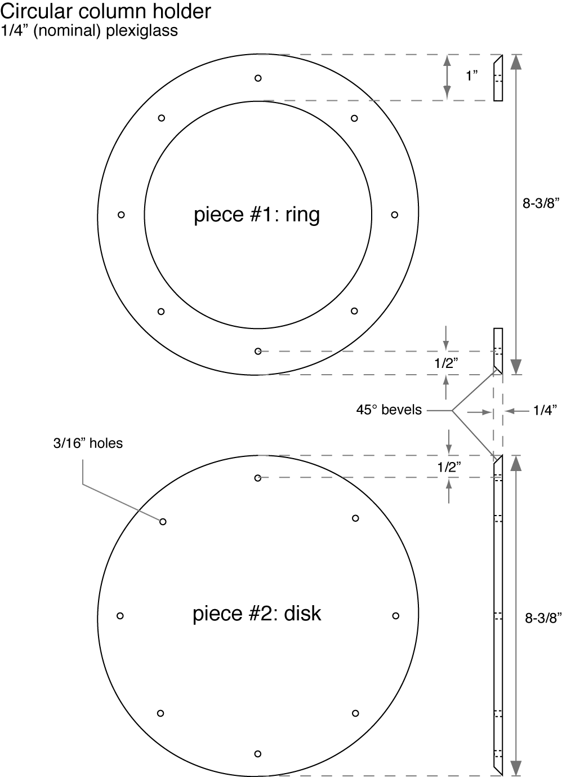

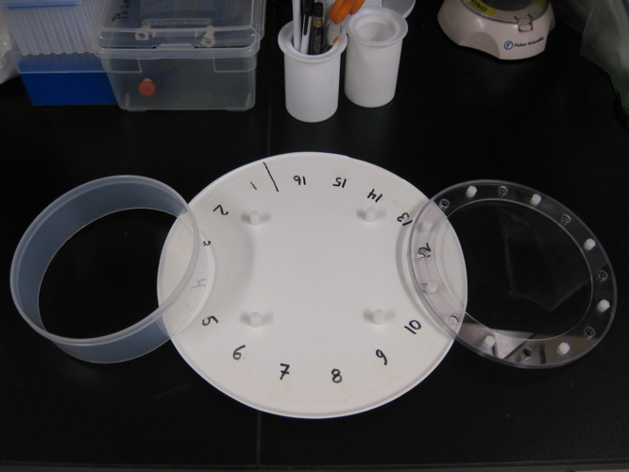 | 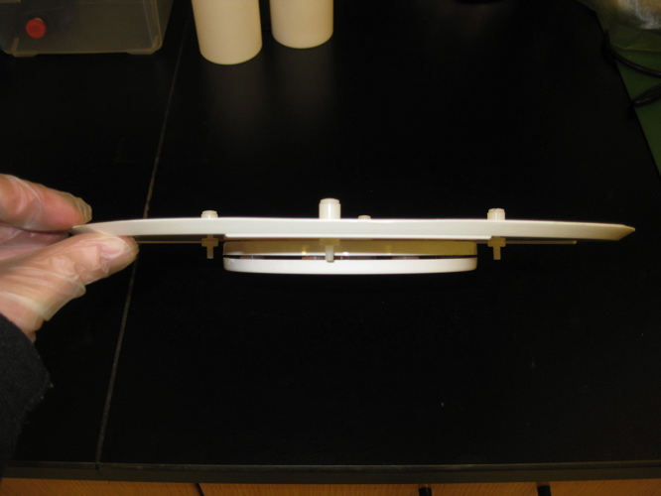
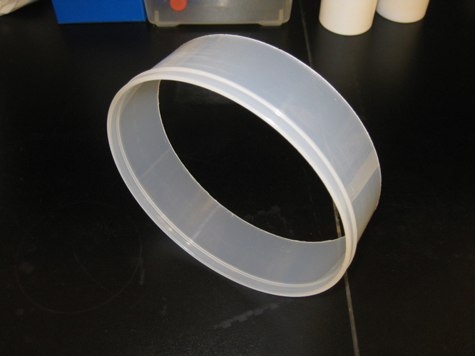 | 