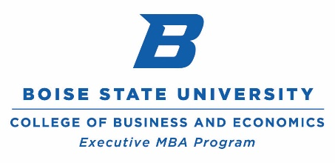
Boise state university

Recommendation for Executive MBA Program

TO THE APPLICANT:

Please fill out the section below and forward this form, via email, to the person you have indicated as a reference on your application form.

Applicant Information
Name of Applicant:
Date Sent to Recommender:

TO THE RECOMMENDER:

Please fill out this form and email it directly to the Executive MBA program at: emba@boisestate.edu. Your prompt completion of this form is important for the applicant to receive full admission consideration.

Confidentiality
The information requested below will be used for the sole purpose of the graduate admission decision and will be held in confidence.

Recommender Information
Signature
Name |  |  |  | Title
Organization |  |  |  | Telephone
Complete Mailing Address
Street
City |  | State |  |  | Zip

 | Exceptional (top 2%) | Very Good (top 10%) | Good  (top 25%) | Average  (top 50%) | Below Avg.  (bottom 50%) | Unable to Assess
Knowledge in chosen field
Motivation and perseverance toward goals
Ability to work independently
Ability to work effectively with others
Writing Skills
Oral Skills
Leadership Skills
Rank the applicant among students or employees in comparable fields

recommendation Data
1. | How long have you known the applicant? In what capacity?
2. | For what reasons do you feel this applicant is qualified to do high-quality graduate work in management? Please explain.
3. | Please comment on the applicant’s greatest strengths and qualifications.
4. | Please comment on the applicant’s weaknesses and potential areas for growth.
5. | How do you see the Executive MBA degree contributing to the applicant’s professional growth and achievement in his / her organization and / or community?

Tel – (208)-426-4034
emba.boisestate.edu
Director, Executive MBA Program
Boise State University
1910 University Drive
Business Building, MBEB 4101
Boise, Idaho 83725-1600

